Reference Architectures
How data is stored and used in a data warehouse

Structure of Reference Architectures
Source System -> ETL -> D.W. -> Multi-Dimensional Data -> Front-End Analysis Tools

Various Database Architectures
Independent Data Marts
Centralized Data Warehouse W/O Dependent Data Marts
Centralized Data Warehouse with Dependent Data Marts
Virtual Data Warehouse
Enterprise Warehouse with Operational Data Store

Independent Data Marts

Centralized Data Warehouse W/O Dependent Data Marts

Centralized Data Warehouse with Dependent Data Marts

Virtual Data Warehouse

Enterprise Warehouse with Operational Data Store

Other Structures
Additional Data Warehouse

Additional Data Warehouse
Used when one needs to aggregate historical data

When to use Operational Data Store (ODS)
Need to access current operational data

SAP Evolutions
SAP ERP -> SAP S/4 HANA
SAP BW -> SAP BW/4HANA
SAP Analytics -> SAP Predictive Analytics with HANA
SAP Cloud/4HANA

Persistent memory (PMEM)
Data retained during power surge; larger size and cheaper than DRAM; low latency compared to disk access

HANA memory – in-memory database
Uses PMEM and DRAM; up to 128 TB; can store entire database

SAP BW/4HANA architecture
Data sources -> HANA data warehouse -> BI clients and/or devices
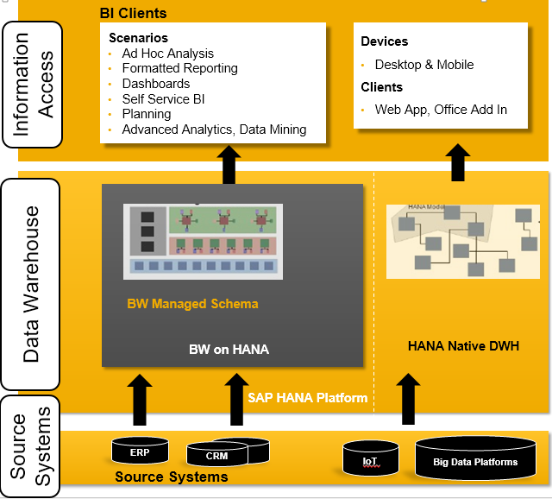

SAP Business Intelligence Platform
Data sources -> BW on HANA data warehouse -> BI clients and/or devices
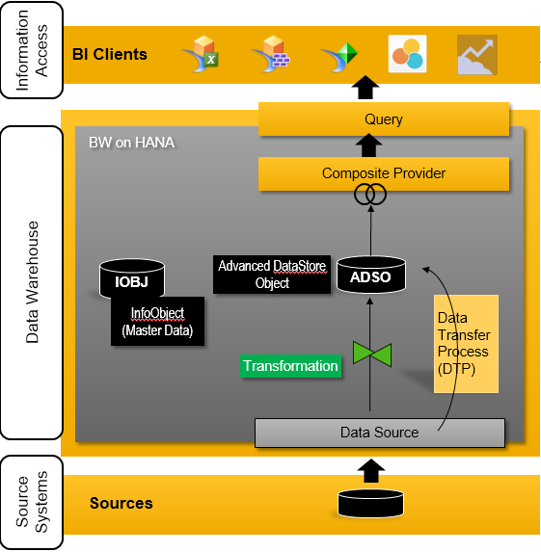

BW on HANA data warehouse components
Data Sources
Modeling objects

Data Source
SAP internal representation of external data

Modeling objects
InfoObjects
Open ODS View
InfoProviders (aDSO, Composite Providers)

InfoObjects
Smallest unit in SAP; “brick”. Viewed as a database field w/ properties and represent business objects from an end-user’s perspective. Store master data.

Master Data
Asdf

Types of InfoObjects
Characteristics
Key Figures

Characteristic InfoObject
Contextual elements; dimensions. Has a key and description; latter is language dependent. Can have many attributes and have attribute hierarchies.

Key Figure InfoObject
Contains KPIs

Union of Characteristics and Key Figures
Reveal facts

Open ODS Views (Operational Data Store)
Allow direct data access w/o InfoObjects; just a view of the data, no persistence (virtualization)

InfoProviders
Give outside clients to data via queries; views of internal data

Types of InfoProviders
aDSO
Composite Providers

aDSO
Stored data physically and consists of InfoObjects and/or ordinary database fields

Three tables in an aDSO
Inbound (where data is written)
Change log
Active data

Reporting in aDSO
Done with union of inbound and active data tables

Composite Providers
Virtual; combines data from other InfoProviders for reporting and analysis; decouples reporting and data storage

ETL
Extract
Transform
Load

Extract
Get data from dsource systems and transfer to a target via an InfoPackage; data goes into a persistent staging area (PSA)

PSA
Inbound data storage

Transform
Data gets clened, consoidated, integrated, and combined from multiple sources

Load
Data flow control; use InfoPackages for loading data

Data Flows Terms
DataSource
Transformation
DTP
Process Chain

Data Flow Picture
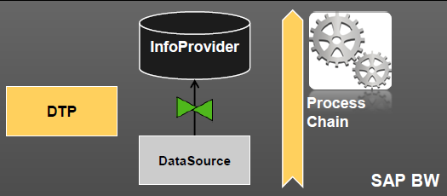

Transformation
Transform data with assigned rules

DTP
Data transfer process

Process Chain
Data flow process pipeline

High-level overview of SAP BW 4HANA

Product -> Material
In SAP, it’s a good practice to store semi-finished and raw materials with products

SAP BW 4HANA Process – ALWAYS LOAD MASTER DATA FIRST; INFO ABOUT FACTS
- Create InfoObjects (Characteristics and Key Figures)
  - Use correct InfoObject type and data type
  - Ensure proper units/aggregation (key figure)
  - Ensure proper length and properties
  - Check other tabs and select options as needed; language dependent may be true for characteristics
  - Choose whether to display the key or something else (characteristic)
  - Check “Useable as InfoProvider” if data will be imported via ETL process
  - Add attributes
- Populate InfoObjects with Data – Manual and ETL
  - Manual – small amnt of data
    - Go to SAP cockpit (fiori)
    - “Data Display and Maintenance”
    - “Info Object Master Data Maintenance”
    - Search for and select InfoObject
    - “Texts”
    - Fill in fields
    - Save and log out
  - ETL – large amnt of data
    - Extract – You may be able to copy data sources and repurpose them
      - Check separator in your data
      - “Data Sources”
      - “File”
      - “Flat-File”
      - Area
      - User Area
      - “New”
      - “DataSource”
      - May copy info from other Data Sources
      - Choose appropriate data source type
      - “Extraction” tab – choose proper settings
      - “Derive fields from file”
      - May need to correct data types, lengths, references, and format settings (internal vs external)
      - Save/activate and check data preview; note internal format option
    - Transform
      - Go to your InfoArea and create a Data Flow object
      - “copy from” if needed
      - Add an InfoObject to the flow canvas
      - Assign correct InfoObject to InfoObject(s) on the canvas
      - Add DataSource to the Data Flow
      - Assign correct DataSource to DataSource(s) on the canvas
      - Hover over DataSource, click thin arrow on side, and drag towards the important InfoObject
      - Double-click the Transformation icon on the InfoObject
      - Copy rules as needed
      - “rules” tab
      - Define transformation rules by dragging/dropping
        - May need to define language key
      - Save/activate the transformation and data flow
    - Load
      - Double-click the DTP icon on the InfoObject (Data Flow)
      - Copy from if needed
      - In the DTP editor, check settings on all tabs
      - Save/Activate DTP editor
      - Click on green bubble w/ arrow (start execution of dtp)
      - “Execute” and go back to DTP tab
      - Save/Activate
      - Check if the DTP on the data flow tab has turned blue. If so, success
      - Go to Fiori to see if the data was loaded properly
- Create and Populate an aDSO
  - Create
    - Create aDSO in InfoArea
    - Select correct datasource
    - May select “Data Mart DataStore Object”
    - Add relevant groups that pull data from InfoObjects
    - Assign fields to groups and correct them to InfoObjects as needed
    - Add/assign InfoObjects as needed
    - Save/activate
  - Populate
    - Create a new Data Flow object
    - Copy From if needed
    - Add a data source into the canvas
    - Assign InfoObject(s) to data source(s)
    - Add the aDSO to the canvas
    - Save/activate
    - Connect one source to the aDSO
    - Create a transformation (see prior notes)
    - Create and execute a DTP (see prior notes)
    - Save all/activate
  - Activate – Make aDSO useable for analytics
    - Log on to Fiori
    - “DataStore Objects Manage Requests”
    - Find your aDSO
    - Select DTP request
    - Activate DTP request
    - Return to Eclipse
    - Go to data flow
    - Save/activate data flow
- Create a CompositeProvider
  - Create composite provider in infoarea
  - “Next”
  - Add aDSO into “Union Providers” (may go into join providers)
  - “Finish” and save
  - “Scenarios” tab
  - Drag from source to target (NOT INDIVIDUAL FIELDS)
  - Save/activate
- Change CompositeProvider’s output structure (if needed)
  - “Output”
  - Add navigation attributes as needed
  - Save/activate
- Create a Query
  - Create query by right-clicking the CompositeProvider
  - “InfoProvider” panel on the left navigation pane
  - “Sheet Definition” tab on the right pane
  - Drag elements from InfoProvider panel to “columns” “rows” etc.
  - Save
  - Check reporting preview to see how query looks to end user
- BI Client Analysis (Excel
  - Open Excel
  - “analysis”
  - “Insert Data Source” dropdown
  - “Select Data Source for Analysis”
  - Follow steps and select query
  - Analyze

SAP Analytics Cloud
- SAP Analytics Cloud webbsite, “Modeler”
- “Create new model”
- “Start with data”, “Next”
- “File”
- Select source, define headers, and import
- Change variables to dimensions/measures as needed
  - Select checkboxes next to variables to convert
  - Three dots in upper left
  - “Convert to X”
- Link related variables (Create proper dimension tables)
  - Select column of interest
  - Put a description if desired
  - Under “Properties”, hit + and select proper property from column list
  - Iterate as needed
- Add hierarchies as needed
  - Select column of interest
  - Hit + close to “Hierarchies”
  - Set up hierarchies
- Delete variables as needed
- Change data types as needed
  - Select column of interest
  - Hit three dots on its row
  - “Change property type”
  - May need to change descriptions; avoid keywords
  - Can change data type from dimension page as well
- Convert dimension w/ attributes to dimension table
  - Select dimension of interest
  - “Generate dimension table”
- Transform columns as needed
  - Select relevant columns
  - In “Data Foundation”, hit “Transform data”
  - Select relevant columns and “Create a Transformation”
  - “Concatenate” or other commands
  - Adjust details panel for new column as needed
- Measure editing as needed
  - Select relevant measure
  - Change data type, currency, and/or unit type

Create SAP Analytics Cloud Stories (Visualizations)
- “stories” tab
- “Canvas”
- “Add data”
- Select proper source
- Convert measures to dimensions or vice-versa as needed
  - Find column
  - Three dots
  - “change to X”
- Transform columns and create hierarchies as needed
- Change data type as needed
  - Must change datatype to correct one before transformations
- “Story” tab
- “Run a smart discovery”
- Select target, entity, and filters
- “Run”
- Add new chart/info
  - Insert new tab
  - Select object to add

